

**American International University- Bangladesh**

**CSC 2209: Object Oriented Programming 1 (JAVA)**

**CO1 Evaluation**

**Project Summary Report**

**Fall 2019-20**

**Group No:**

**Project Title: Doctor Appointment & Medicine**

|  |  |
| --- | --- |
| Student Name | Student Id |
| Aseya Khanom | **17-35394-3** |
| Bushra Amana | **18-36568-1** |
| Shafin Talukder | **18-36588-1** |
| Arshad Hassan Aywon | **18-36601-1** |

**Introduction:**

The problem of the crisis of rare unavailable medicine from abroad can be solved using a simple shipping system to buy medicines from abroad. So, we are thinking about making an application system in which we will make the rare and expensive medicines available anytime from all over the world. As we want to solve this problem, we need to create a system which will save our time & money and provide medicine as soon as possible. The goal of our application is to make a way that can provide rare medicine available anytime. For the second problem of making an appointment the concept of our application which will bring the change is one can make the appointment with any doctors who is appointed in any medical contra’s in all over the country. So, the theme is we are getting all the doctors list in just one application. By this the appointment system will be much more efficient to use.

So, the benefits of the application are

* Save a huge amount of time, energy and money.
* Make the wanted unavailable medicines available anytime.
* Get the appointment sitting anywhere in the country.

**User Category:**

There are two types of Users here. They are:

* Admin
* User

**Feature List:**

In this project the **Admin** has the following features:

* Grants / deny access to member.
* Manage users and admins right.
* Block user

In this project the **User** has the following features:

* Appoint doctor.
* Order medicines.
* Payment flexibility.
* Security.
* Choose Quantity.

**GUI Description:**

User has to provide proper Phone Number & Password to Login his/her account. If you don’t have an account, then you have to Registration first.

Giver proper information to Register your account.

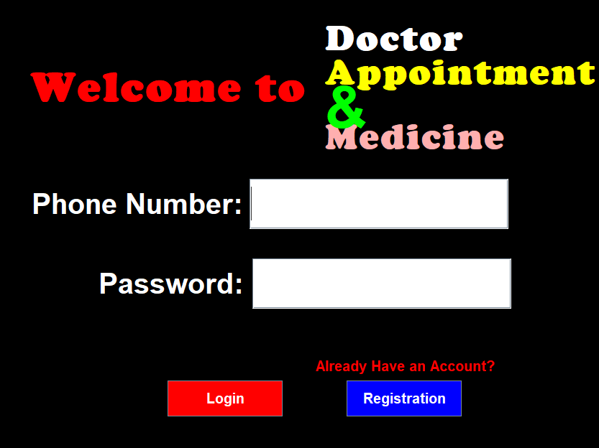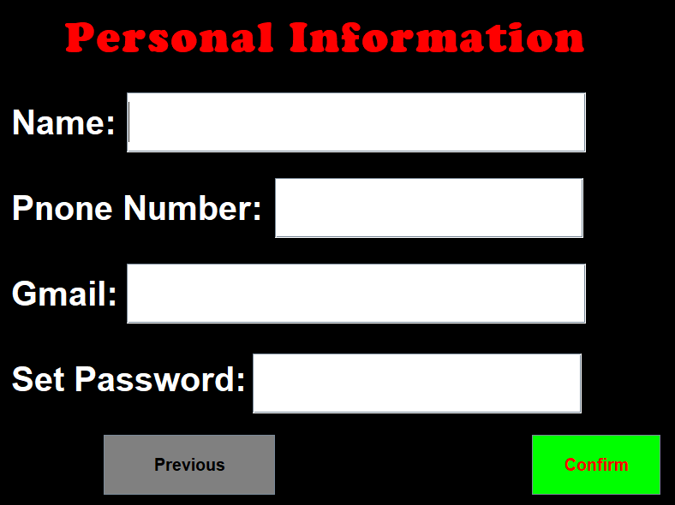

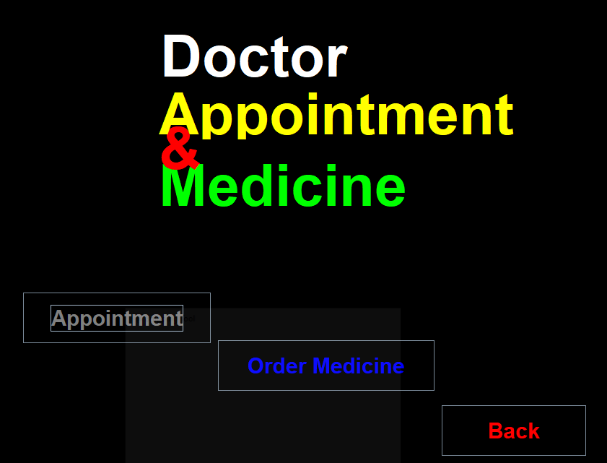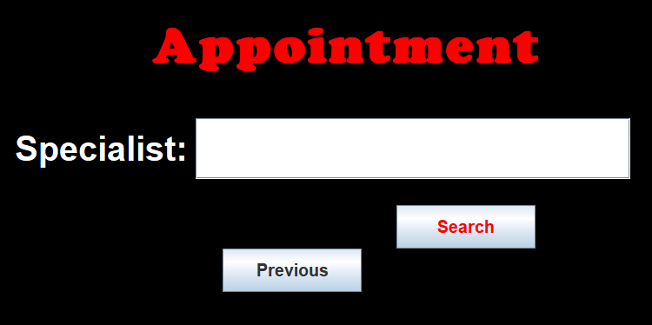

Choose your option.

You can search your doctor via specialist.

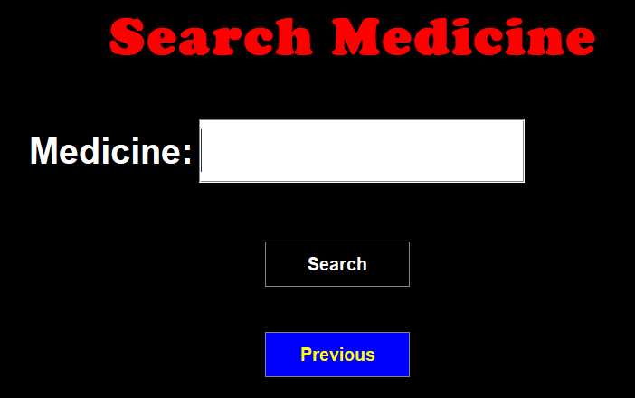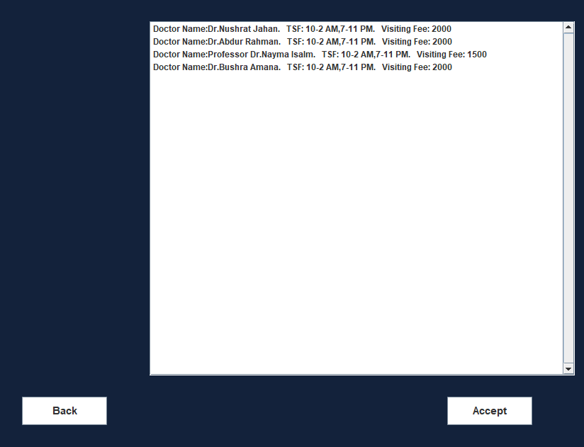

Confirm your doctor’s appointment after searching via specialist.

Search your medicine

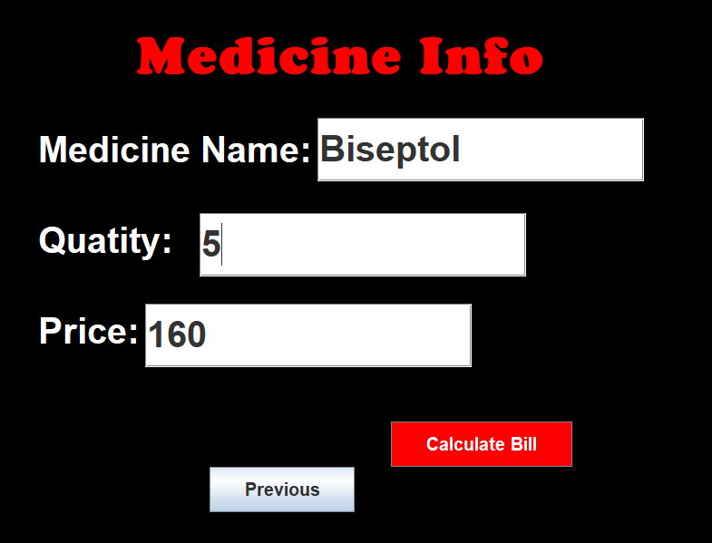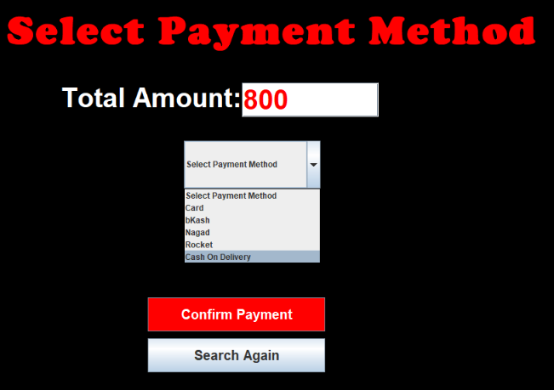

Calculate Total Bill after entering your suitable quantity.

Select your suitable payment system.

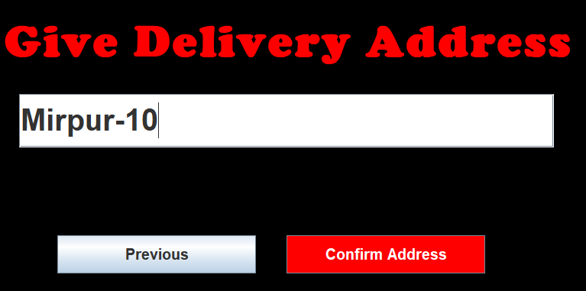

Delivery address is required to confirm your order.

**Database Table Description:**

**user**

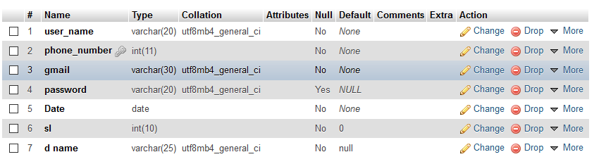

**medicine**

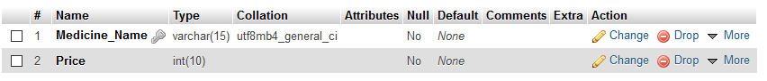

**unavailable**

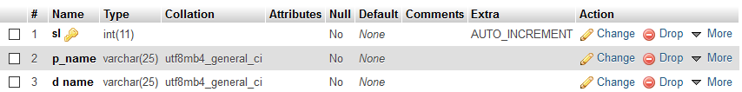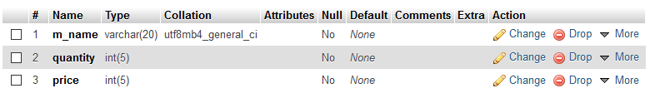

**appointment**

**order**

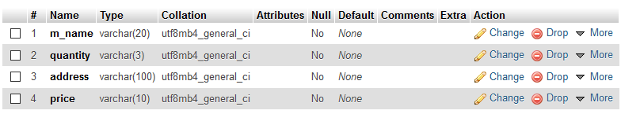

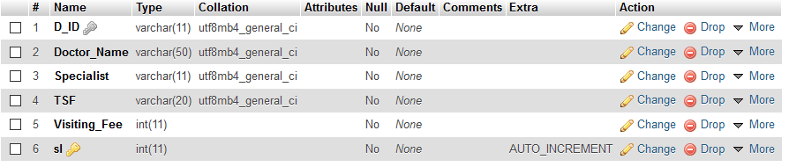**doctor_information**

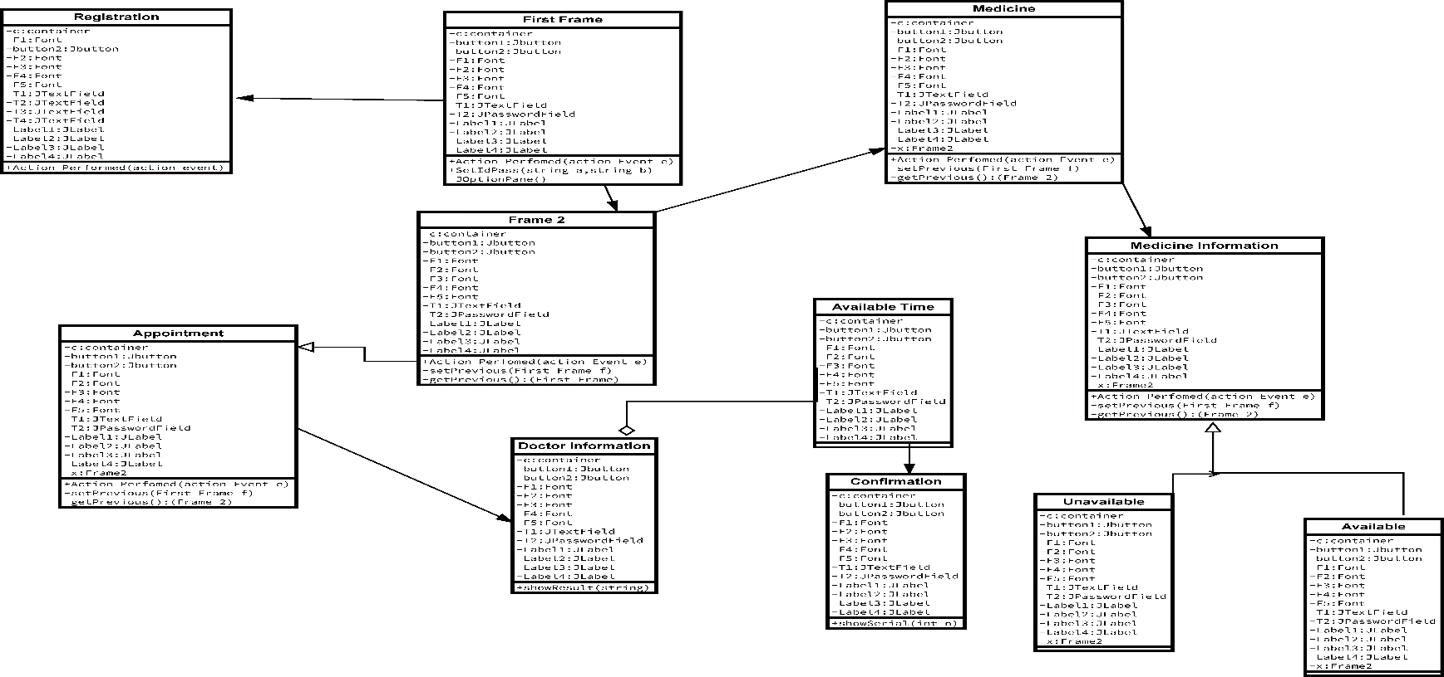**Class Diagram:**

**Tools Used:**

To develop this project, we have used the following:

* NetBeans
* Xampp
* JDBC Connector
* Codes

**OOP and Java Concepts Used:**

* Concept 1: Inheritance.
* Concept 2: Interface.
* Concept 3: Exception Handling.
* Concept 4: Graphical User Interface.
* Concept 5: Java Database Connectivity.
* Concept 6: Events.
* Concept 7: Array List.

**Impact of this Project:**

By the help of our application the user can get the rare medicines in just a week or may even less than that. Besides they are also getting all the doctor’s info who are appointed in each and every hospitals and medicals in our country in just one app. Applications like AMAZON, ALIBABA.COM can ship things which are used in or daily life but there is hardly any software which ca ship medicines. The major benefits of the application are; (i)Save a huge amount of time, energy and money. (ii)Make the wanted unavailable medicines available anytime. (iii)Get the appointment sitting anywhere in the country.

**Limitations and Possible Future Improvements:**

**Limitations:**

This project is only applicable for inner Dhaka. Out of the Dhaka it’s not workable. When user will order medicine that time the system will take some time to delivery. The available medicine is delivered within 7 days. And the medicine which is not available that will take 15 days to delivery.

**Possible Future Improvements:**

This project can be improved by adding some features like we can make it workable for not only in Dhaka but also in the whole country. And we will less the time of the delivery. Our project now will allow the user to make the appointment only but in future after some upgradations it will also help the user to upload the test results online which will be suggested by the appointed doctor. Thus, a lot of time and money can be saved.